Relational work

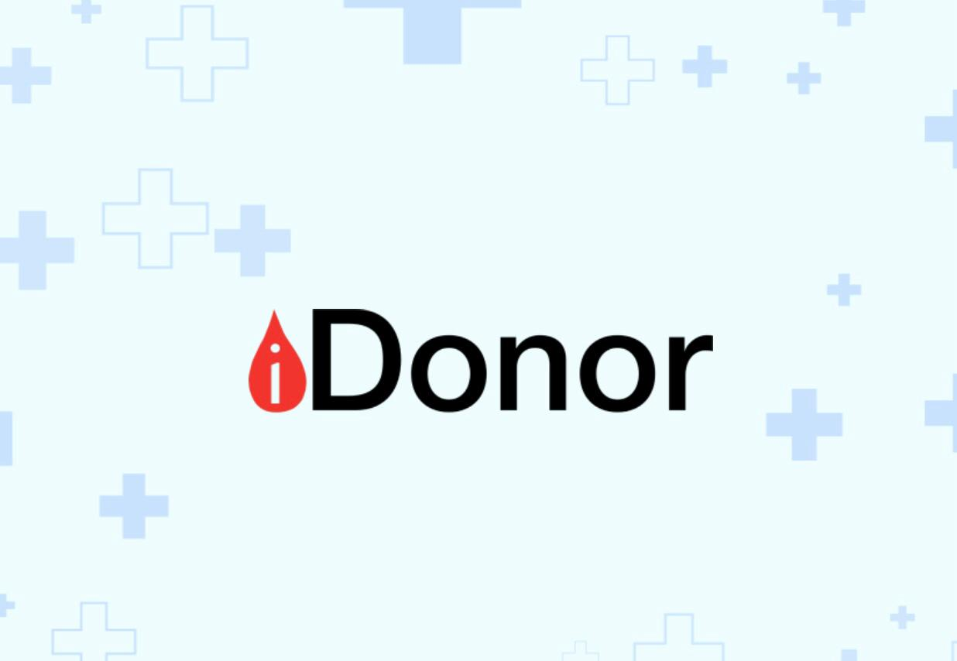

1. Review about iDonor

An application that helps establish a link between the person who needs blood and the person who can donate blood, which saves the trouble of searching for a blood donor.
The program is divided into two parts: the first part is that the user donates and the second part is that the user searches for a donor, so he chooses the blood type he is looking for.
A person with type “B+” receives a warning in the event of a need for blood type “B+”. If the subscriber donates blood, he does not receive any warning regarding the blood request for two months, as the person cannot donate blood again until two months have passed.

The difference between iDonor and our project
- The user can also test his health and not just donate blood.
- It will can determine the location of the user.
- Users who register will receive notifications when someone within 5 miles needs blood, enabling them to donate at nearby clinics.
- Raising awareness of the benefits of blood donation and contraindications for blood donation
- Includes incentives to encourage regular blood donation. Every successful donation earns the donor a star.

____________________________________________________________________________________

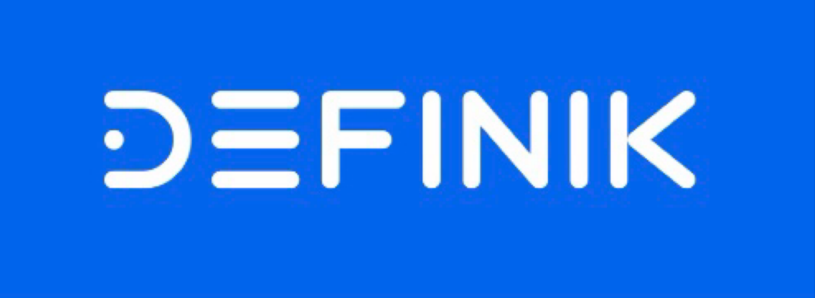

2. Review about Definik
Definik is a fast and cheap solution for early risk detection of common diseases by analyzing laboratory blood tests and creating personalized plan for further monitoring with regular recommendations based on AI.
Definik includes regular monitoring, which helps to track changes in the user's health status and provides timely recommendations.
With Definik users can receive early risk detection of a range of conditions allowing them to take action before symptoms worsen.
This personalized approach ensures that users receive the support they need to manage their health proactively.
Everyone can use Definik because of its simple interface.
With Definik, users can take control of their health and live life to the fullest.
The difference between Definik and our application.
– Definik application:
- The diagnosis of diseases depends on laboratory blood tests.
– our application (blood samples):
• The diagnosis of diseases depends on several questions and inquiries related to the user in order to know the predicted disease and the way to reach an appropriate solution.
• It will connect with someone of relatives to alarm him if the user in danger.

____________________________________________________________________________________

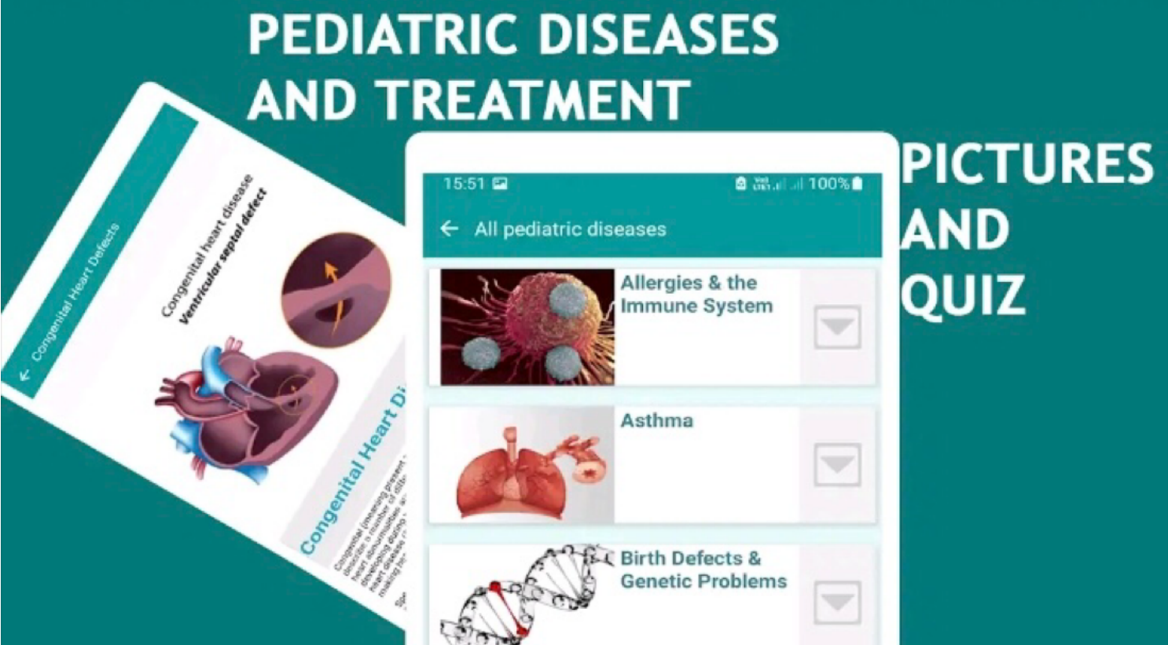

3. Review about Pediatric diseases and treatment
Pediatric disease and treatment app is for childhood diseases, treatment and it's suitable for children's doctor, nurses, midwife and dentist This Pediatrics book / disease treatment book offers all children diseases (childhood diseases), disease symptoms, causes, diagnosis, treatment of all disease and pediatric drug dose calculators, blood pressure calculator, emergency guide, pediatric nursing quiz, weight calculator and other health calculators.
Pediatric diseases and treatment app is one of the clinical medicine books for pediatric diseases with all kids diseases, pediatric conditions, disease symptoms and diagnosis, diseases and treatment drugs, pediatric protocol, medical terminology and a dosage guide.
the difference between Pediatric diseases and our application.
– pediatric diseases application:
- It is concerned with predicting children's diseases only.
– our application (blood samples):
- It is concerned with predicting diseases of all ages, from three years old to older ages

